Registration form Lwengo Kids Foundation
Primary and /or Secondary School
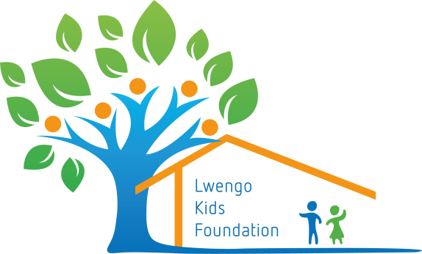

I would like to help a child in Lwengo and donate the amount below in the following way:

- I pay € 150,-- per year per child as long as he or she attends LWERUDESO Primary School.

- I pay € 240,-- per year per child as long as he or she stays at Boarding School and goes to LWERUDESO Primary School.

- I pay € 450,-- per year per child as long as he or she goes to Secondary School.
- I would like to give a donation and deposit it on the account NL75 TRIO 0379 3857 67 t.n.v. Lwengo Kids Foundation in Putten, o.v.v. one-time gift

Name: ……………………………………………………………………………………………………..…………………
Address: …………………………………………………………………………………………………..……………………
Zipcode and city: ……………………………………………………………………………………………………………….……...
Country: ………………………………………………………………………………………………..……………………..
Phone: ………………………………………………………………………………………………..………………………
Email: ………………………………………………………………………………………………………………………..

You may send or email the form to
Marga Streefkerk, Bakkerstraat 2, 3882 AA Putten, the Netherlands
mail: lwengokids@gmail.com
telefoon: 0031 6 1307 1167

Kamer van Koophandel onder nummer 68254237 - ANBI-geregistreerd

