Registration form Lwengo Kids Foundation
Secondary School / Vacational School / Gift study found
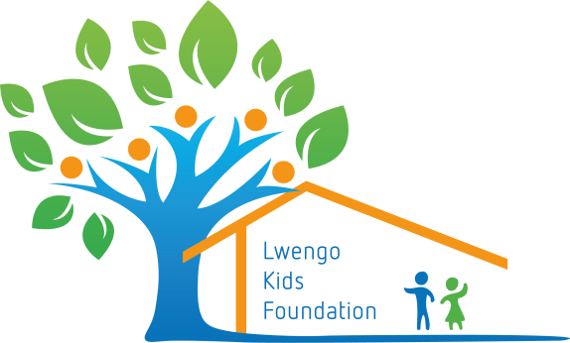

I would like to help a student in Lwengo and donate 450, - or the agreed amount per year for his / her further education, to be paid in the following way:
- Monthly installments (to be determined), starting from the moment you receive notification from us to deposit your contribution.
- Once a year € 450, - or the agreed amount, to be paid when you receive a message from us to pay your contribution.
- I would like to make a donation for the study fund and transfer it to the account
NL75 TRIO 0379 3857 67 t.n.v. Lwengo Kids Foundation in Putten, o.v.v. gift study fund

Name: ……………………………………..………………………………………………………………………
Address: ………………………………………………………………………………………………………………
Zipcode ………………………………………………………………………………………………………………
City: ………………………………………………………………………………………………………………
Country: …………………………………………………..………………………………………………………...
Phone: ………………………………………………………………………………………………………………
Email: ……………………………………………………………………………………………………………..

You may send or email the completed form to
Marga Streefkerk, Bakkerstraat 2, 3882 AA Putten
mail: lwengokids@gmail.com
telefoon: 06 1307 1167

Kamer van Koophandel onder nummer 68254237 - ANBI-geregistreerd

